Name:  Exit Ticket  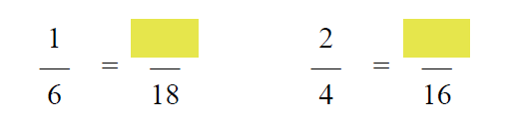  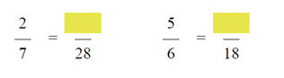  Which fraction is smaller?  $$\frac{1}{4} or \frac{1}{2}$$  $$\frac{1}{5} or \frac{1}{3}$$ | Name:  Exit Ticket  Which fraction is smaller?  $$\frac{1}{4} or \frac{1}{2}$$  $$\frac{1}{5} or \frac{1}{3}$$

